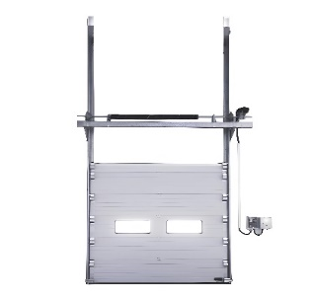
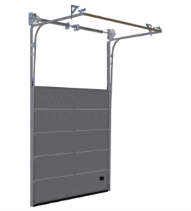
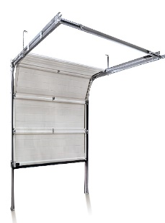
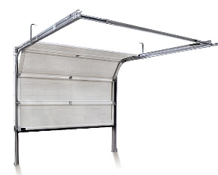
Vertical head lift
High head lift
Standard head lift
Lower head lift
NIHVA Vertical Head Lift Door:
- Suited for spaces with ample vertical headroom, enabling the door to lift directly upwards without necessitating additional clearance.

- Particularly beneficial for settings prioritizing maximum vertical space utilization, such as warehouses and industrial facilities.

NIHVA Standard Head Lift Door:
- A versatile option suitable for various settings, striking a balance between headroom requirements and door height.
- Commonly deployed in both residential and commercial applications, where moderate headroom is available.

NIHVA High Head Lift Door:
- Offers heightened clearance compared to standard head lift doors, making it ideal for environments with elevated ceiling heights.
- Provides increased flexibility in accommodating larger vehicles or equipment, catering to diverse industrial and commercial needs.
NIHVA Lower Head Lift Door:
- Tailored for spaces with restricted headroom, providing a solution for environments where ceiling clearance is limited.
- Facilitates the installation of sectional doors in areas with lower ceilings, optimizing spatial utilization without compromising functionality.
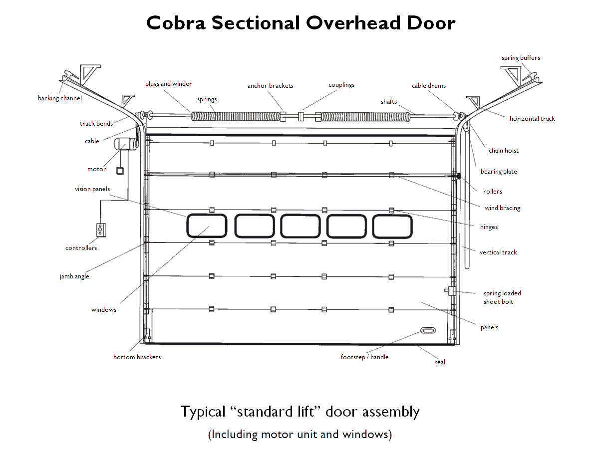
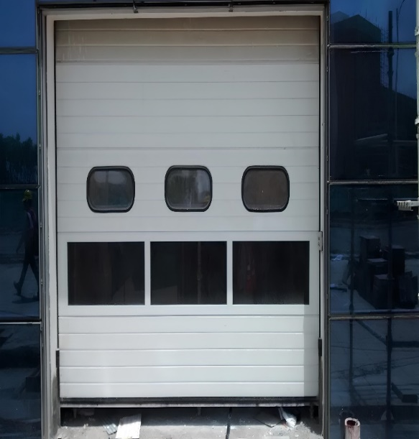
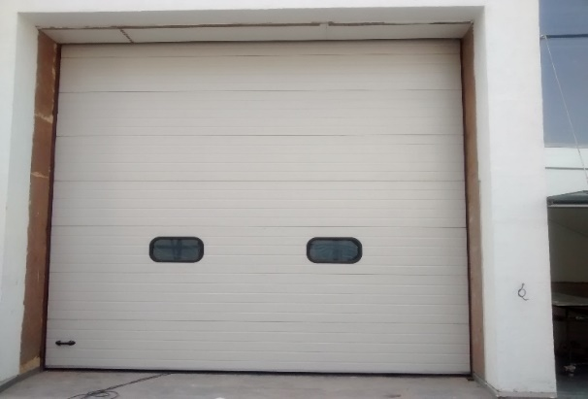
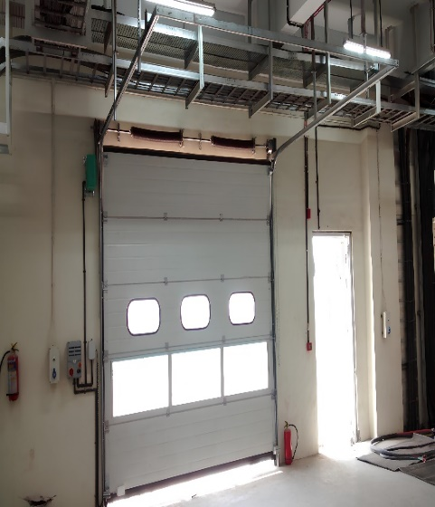
General Drawing

Input Voltage | AC220V | AC220V | AC380V | AC380V
Rated Power | 300W | 500W | 300W | 450W
Start-up Torque | 35N.m | 60 N.m | 60 N.m | 100 N.m
No-load running time | 15min | 15 min | 25 min | 25 min
Max Door Weight | 15m2 | 25 m2 | 25 m2 | 35 m2
Thermal Protective | 120°c | 120°c | 120°c | 120°c
Mode of supportive | Split | Split | Split | Split
Motor Specification

